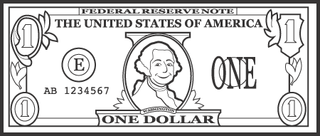
If I Had a Dollar
By: Kenn Nesbitt
If I had a dollar I know what I’d do;
I’d go to the mall and I’d spend it on you.
I’d shop for a shoelace, or maybe a sock,
Or maybe a ribbon, or maybe a rock.

I’d pay for a pickle, a pear, or a plum.
I’d get you a grape, or a half-pack of gum.
I’d spring for some string if the string were on sale.
I’d purchase a pinky-sized pink plastic pail.
Stanza
A stanza is a group of lines in a poem, separated by space from other stanzas. A stanza looks like a paragraph that you would read in a story.

Line
A line is a single row of words in a poem.
Rhyme Scheme
A “rhyme scheme” is a way of describing the pattern of end rhymes in a poem. Each new sound at the end of a line is given a letter, starting with “A,” then “B,” and so on. If an end sound repeats the end sound of an earlier line, it gets the same letter as the earlier line.

Repetition
Repetition is repeating words, phrases, lines, or stanzas. Repetition is used to: emphasize a feeling or idea, create rhythm and/or develop a sense of urgency.

I’d pick up a pencil, I’d give you a stick.
I’d buy you a bit of a board or a brick.
I like you, I do, but I’m sorry to say
You can’t get a lot for a dollar today.

Lucky Listener Signatures:
X ______________________________
X ______________________________
X ______________________________

