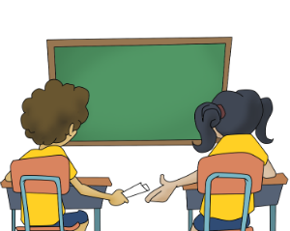
Peter Passed a Note Today
By: Kenn Nesbitt

Peter passed a note today.
He gave the note to Anna.
She opened it and read it,
Then she passed it on to Hannah.

The note made Hannah giggle
So she handed it to Cody,
Who read it with a smile before
He slid the note to Brody.

Then Brody read the contents
And he gave it to Luann,
Who opened it and chuckled
And directed it to Dan.

Lucky Listener Signatures:
X ______________________________
X ______________________________
X ______________________________

He read it with a snicker,
Then he tossed the note to Jon
Who couldn’t help but chortle
As he passed it on to Sean.

The teacher heard us laughing
And she saw what Sean was holding.
She walked across the room
And took the note he was unfolding.

We thought we’d get in trouble,
But she gave it back to Sean
And smiled because it read,
“The teacher’s awesome. Pass it on.”

