Martin Luther King Jr. – Love Each Other
By: Nikki Aksamit
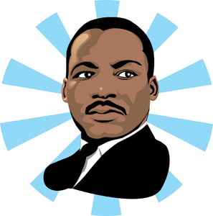
Born in 1929,
He worked hard to erase the line
Between the races – blacks and white.
He used his words to win the fight.
Everyone on one big team,
“Equal rights for all” was his dream.
Martin Luther King Jr. spoke of peace,
Hoping that hatred would someday cease.
Stanza
A stanza is a group of lines in a poem, separated by space from other stanzas. A stanza looks like a paragraph that you would read in a story.

Line
A line is a single row of words in a poem.
Rhyme Scheme
A “rhyme scheme” is a way of describing the pattern of end rhymes in a poem. Each new sound at the end of a line is given a letter, starting with “A,” then “B,” and so on. If an end sound repeats the end sound of an earlier line, it gets the same letter as the earlier line.

Repetition
Repetition is repeating words, phrases, lines, or stanzas. Repetition is used to: emphasize a feeling or idea, create rhythm and/or develop a sense of urgency.

By loving each other,
each woman and man,
We can complete his Nobel plan.
Lucky Listener Signatures:
X ______________________________
X ______________________________
X ______________________________

